Task 1: Documentation
  - Database Initialization:
Navigate to the /Database folder and execute Lewisretail.sql (to be treated as the Lewis Retail Schema). Verify the presence of 5,000+ stock and pricing records.
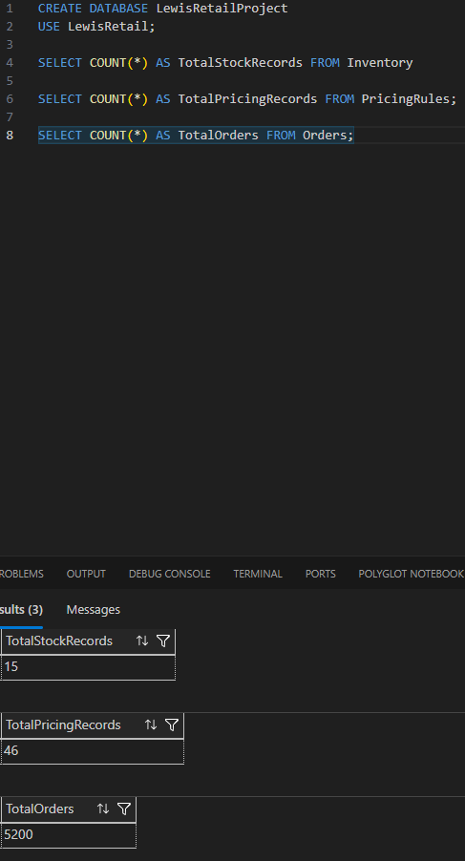
1.2 API Deployment:
Initialize the Retail API in the /API folder. Verify that the endpoints for Stock, Pricing, and Credit are documented and accessible via the local Swagger gateway.
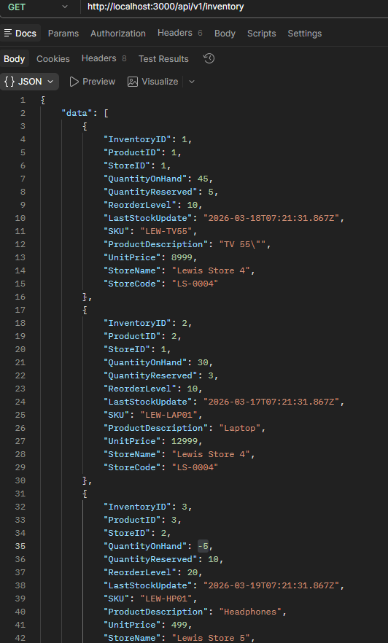
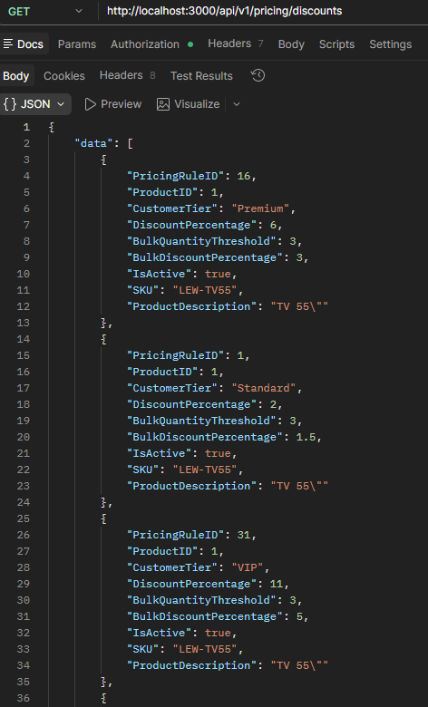

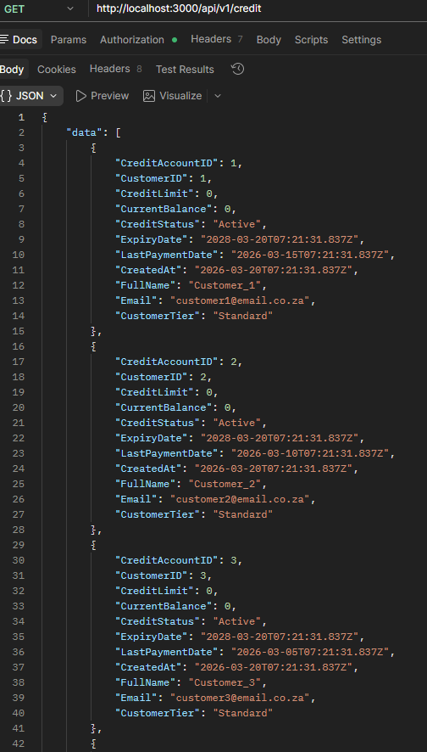

  - JIRA Project Management:
Every team member must create a JIRA board. All project work must be broken down into User Stories, Sub-tasks, and Bugs. No work is considered "done" unless it is moved to "Done" in JIRA with evidence attached.
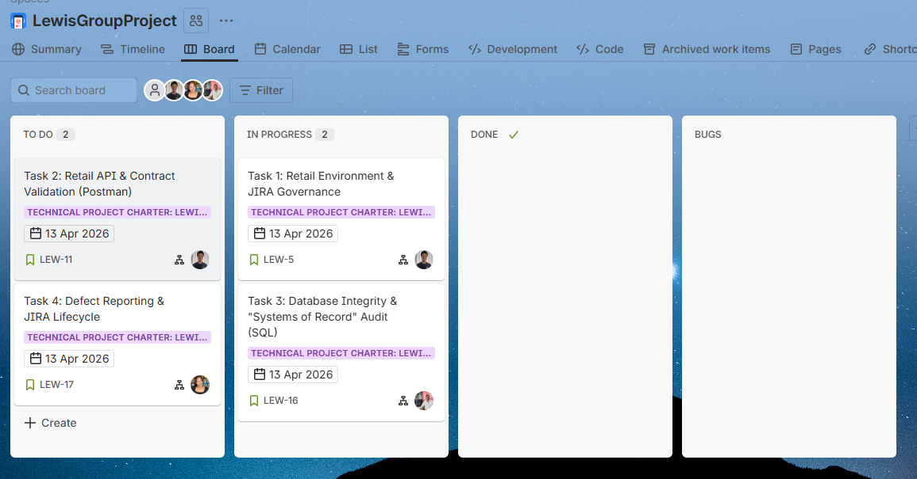

  - Git Architecture:
Establish a shared repository. Sprinters must demonstrate an audit trail via feature/ branches and Pull Requests. Direct commits to main are strictly prohibited.
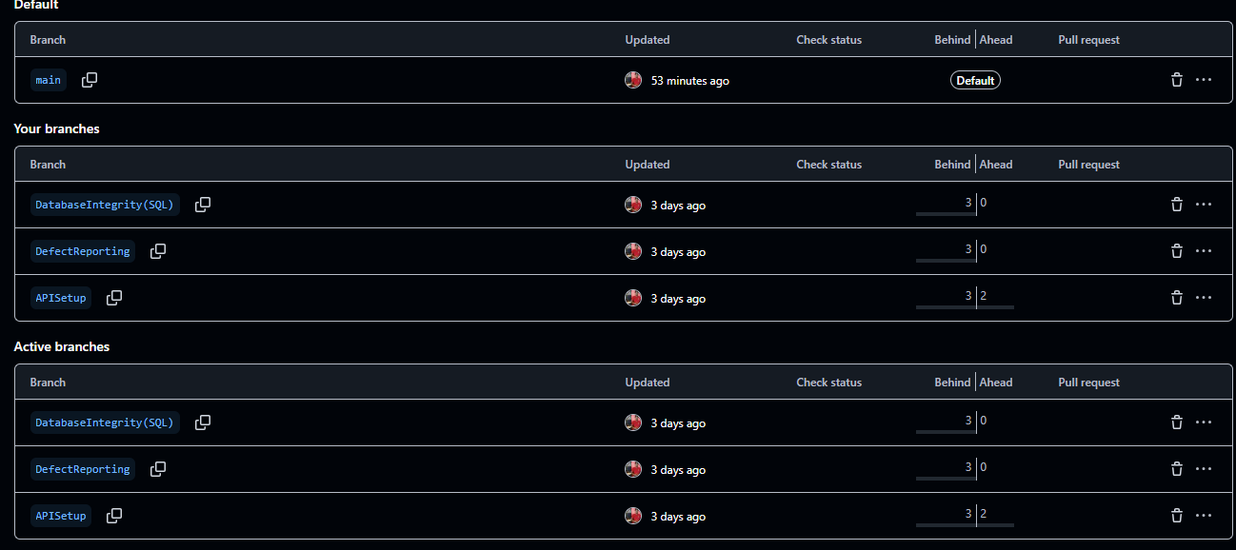

Task 1 Question:
Explain how the integration of JIRA and Git supports the "Traceability" principle in a retail environment when a pricing defect is discovered in production.
By establishing a transparent, end-to-end connection between a production defect and its resolution, the integration of Jira and Git promotes the traceability principle in a retail setting. When a price error is found, it is initially reported as an issue on Jira, where all pertinent information is entered, including the problem description, impact, and priority. In order to make sure that every code modification made to address the problem is directly linked to the defect, developers then refer to this Jira ticket in their Git branches and commit messages.
This integration allows stakeholders to trace the lifecycle of the issue—from identification and code changes to testing and deployment—providing full visibility and accountability. As a result, any pricing error can be tracked back to its root cause, the exact code modifications made, and the validation steps taken, ensuring better quality control and more reliable system maintenance in the retail environment.

